A
Project Report on

“Swiggy Dataset”
Submitted at
Fortune Cloud Technology, Pune

Submitted by:
Gauri Arun Pise

Email:
gauripise190@gmail.com

Guided by:
Varsha Patil

Technology Used:
Microsoft Excel
Microsoft Power BI
Tableau Public Edition

Batch:
6th Jan,2025

: ˙ . Project Report: Spotify Dataset

INDEX

Section | Title
1 | Project Title
2 | Objective
3 | Tools & Technologies Used
4 | Insights (Chart by chart)
5 | Screenshots
6 | Challenges Faced
7 | Conclusion
7 | Future Scope

1)Project Title: Swiggy Dashboard

2)Objective:
The primary objective of this Swiggy dashboard is to analyze and visualize key metrics related to customer orders, restaurant performance, and delivery trends. The dashboard aims to provide actionable insights for data-driven decision-making by Swiggy’s operations, marketing, and strategy teams.

3)Tools and Technologies :
From above dataset I have created three dashboards in which I used three tools :
a)Microsoft Excel
b)Microsoft Power BI
c)Tableau Public Edition

4)Insights: Chart-by-chart analysis

A)Excel:

1)Chart Type: Column chart
Insight: Count of orders by city
Minimum count of orders : 14914 and City : Pune
Maximum count of orders : 25022 and City : Bangalore

2) Chart Type Column chart
Insight: Delivery fee vs discount applied
Minimum delivery fee :897388.94, City : Pune
Maximum delivery fee:1498608.87, City : Bangalore
Minimum discount applied:1192645.23, City: Pune
Maximum discount applied:2018314.98, City: Bangalore

3) Chart Type: Bar chart
Insight: Discount applied by payment mode
Minimum discount applied:2398569.91, Payment mode: UPI
Maximum discount applied :3221865.94, Payment mode: Card

4) Chart Type: Pie chart
Insight: Payment mode distribution
Minimum count :29825(29.83%),Payment mode: Cash
Maximum count:40240(40.24%),Payment mode: Card

5) Chart Type: Bar chart
Insight: Order count by cuisine type
Minimum order count :19812,Cuisine type: South Indian
Maximum order count:20188, Cuisine type: Fast Food

6) Chart Type: Pie chart
Insight: Count of prepaid
Yes:49935(50%)
No:5006(50%)

7) Chart Type: Column chart
Insight: Revenue by city
Minimum revenue: 11627648.33 ,City: Pune
Maximum revenue:19605812.11, City: Bangalore

8) Chart Type: Clustered bar chart
Insight: Sum of rider and user rating by city
Minimum rider rating: 63350.7,City: Pune
Maximum rider rating:106446.1, City: Bangalore
Minimum user rating: 63383.9 ,City: Pune
Maximum user rating:106333.4, City: Bangalore

9) Chart Type: Column chart
Insight: Item count by cuisine type
Minimum item count: 59276, Cuisine type: South Indian
Maximum item count: 60576 ,Cuisine type: Fast Food

B)Microsoft Power Bi:
Dashboard Objective:
To provide a comprehensive view of Swiggy's business performance by analyzing customer orders, delivery efficiency, restaurant ratings, and city-wise trends to support operational and strategic decision-making.

1) Chart Type: Bar chart
Insight: Order id count by city
Minimum order count :11922905 and City: Pune
Maximum order count:20125518 and City: Bangalore

2) Chart Type: Area chart
Insight: Order id count by year and month
Minimum order count :3129 ,Year : 2024, Month: June
Maximum order count :8593,Year : 2025, Month: March

3) Chart Type: Stacked Bar chart
Insight: Orders count by cuisine type and city
Minimum order count :2878,City : Pune, Cuisine type: South Indian
Maximum order count :5059,City :Bangalore, Cuisine type: Fast Food

4) Chart Type: Pie chart
Insight: Payment mode distribution
Minimum count :29825(29.83%),Payment mode: Cash
Maximum count:40240(40.24%),Payment mode: Card

5) Chart Type: Bar chart
Insight: Avg discount applied by city
Minimum avg discount :79.82 ,City : Delhi
Maximum avg discount : 80.66,City :Bangalore

6) Chart Type: Donut chart
Insight: Count of is prepaid by payment mode
Minimum count of is prepaid :29825(29.83%),Payment mode: Cash
Maximum count of is prepaid :40240(40.24%),Payment mode: Card

7) Chart Type: Stacked bar chart
Insight: Rider rating and user rating by city
Minimum sum of rider rating:63350.70, City:Pune
Maximum sum of rider rating:106446.10,City:Bangalore
Minimum sum of user rating:63383.90, City:Pune
Maximum sum of user rating:106333.40,City:Bangalore

8) Chart Type: Column chart
Insights: Count of peak hour by city
Minimum peak hour count:14914,city:Pune
Maximum peak hour count:25022,city:Bangalore

9) Chart Type: Donut chart
Insights: Count of order id by year
Minimum count of order: 46482(46.48%),year: 2025
Maximum count of order53518(53.52%),year:2024

10) Chart Type: Treemap chart
Insights: Revenue by city
Minimum revenue:11627648.33, City: Pune
Maximum revenue:19605812.11, City: Bangalore

11) Chart Type: Bar chart
Insights: Count of prepaid by city
Minimum prepaid count: 14914 , City: Pune
Maximum peak hour count:25022, City: Bangalore

12) Chart Type: Clustered column chart
Insights: sum of delivery fee and sum of discount applied by city
Minimum delivery fee:897388.94 , City: Pune
Maximum delivery fee :1498608.87, City: Bangalore
Minimum discount applied:1192645.23, City: Pune
Maximum discount applied : 2018314.98, City : Bangalore

13) Chart Type: Column chart
Insights: Count of order by peak hour
Minimum count of orders: 41959, Peak hour: Y
Maximum count of orders: 58041, Peak hour: N

14) Chart Type: Donut chart
Insights: Cuisine type distribution
Minimum cuisine count: 19812(19.81%) , Cuisine type: South Indian
Maximum cuisine count: 20188(20.19%), Cuisine type: Fast Food

15) Chart Type: Bar chart
Insights: Top 10 high value customers
Minimum sum of total amount: 369.34
Maximum sum of total amount:1469.02

C) Tableau Public Edition

1) Chart Type: Bar chart
Insight: Order id count by city
Minimum order count :11922905 and City: Pune
Maximum order count:20125518 and City: Bangalore

2) Chart Type: Line chart
Insight: Order id count by year and month
Minimum order count :3129 ,Year : 2024, Month: June
Maximum order count :8593,Year : 2025, Month: March

3) Chart Type: Column chart
Insight: Sum of delivery fee by city
Minimum delivery fee: 897389, City : Pune
Maximum delivery fee : 1498609, City: Bangalore

4) Chart Type: Packed bubbles
Insight: City wise avg user rating
Minimum user rating: 4.2475 (19.99%), City: Hyderabad
Maximum user rating: 4.2520(20.01%), City: Mumbai

5) Chart Type: Bar chart
Insight: Top 10 high value customers by city
Minimum amount : 1577.17, City: Delhi
Maximum amount: 1591.72, City: Pune

6) Chart Type: Treemap chart
Insight: City wise total amount
Minimum amount: 11627648, City : Pune
Maximum amount: 19605812, City: Bangalore

7) Chart Type: Pie chart
Insight: Cuisine type distribution
Minimum sum of orders: 15856373, Cuisine type: South Indian
Maximum sum of orders : 16211624, Cuisine type: Fast Food

8) Chart Type: Bar chart
Insight: Top 10 restaurant by order value
Minimum order value: 1499.8300
Maximum order value :1500.0000

9) Chart Type: Pie chart
Insight: Count of order id by peak hour
Yes : Count of order value : 41959, Order value : 33738899
No : Count of order value:58041, Order value : 46441293

10) Chart Type: Packed bubbles
Insight: City wise avg rider rating
Minimum avg rider rating: 4.2477, City : Pune
Maximum avg rider rating: 4.254100 , City : Bangalore

5)Screenshots:
A)Excel Dashboard

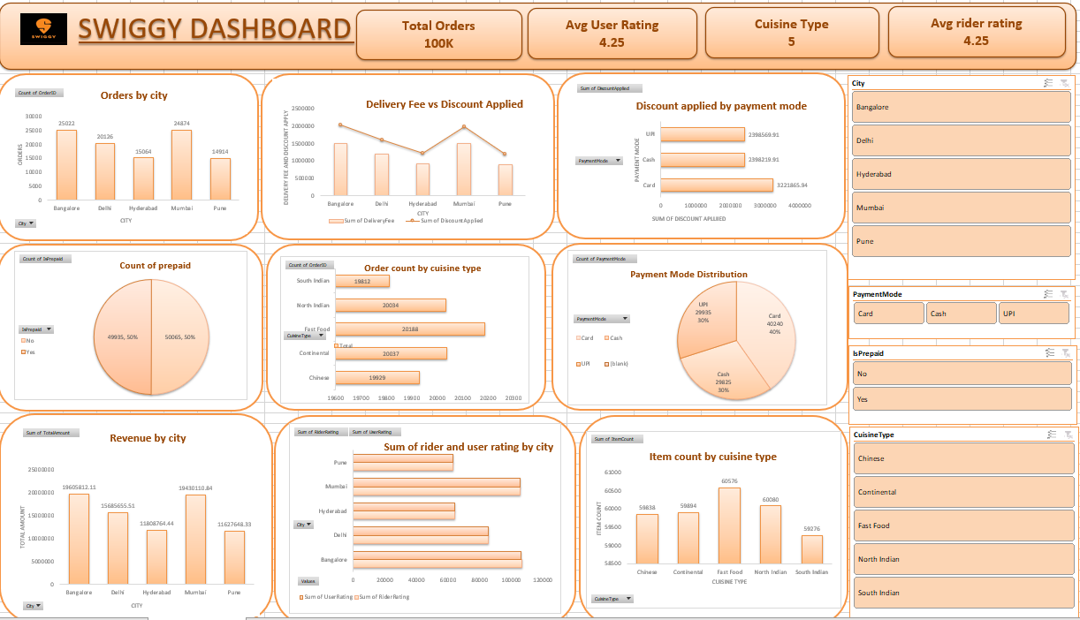

B)Microsoft Power BI Dashboard:
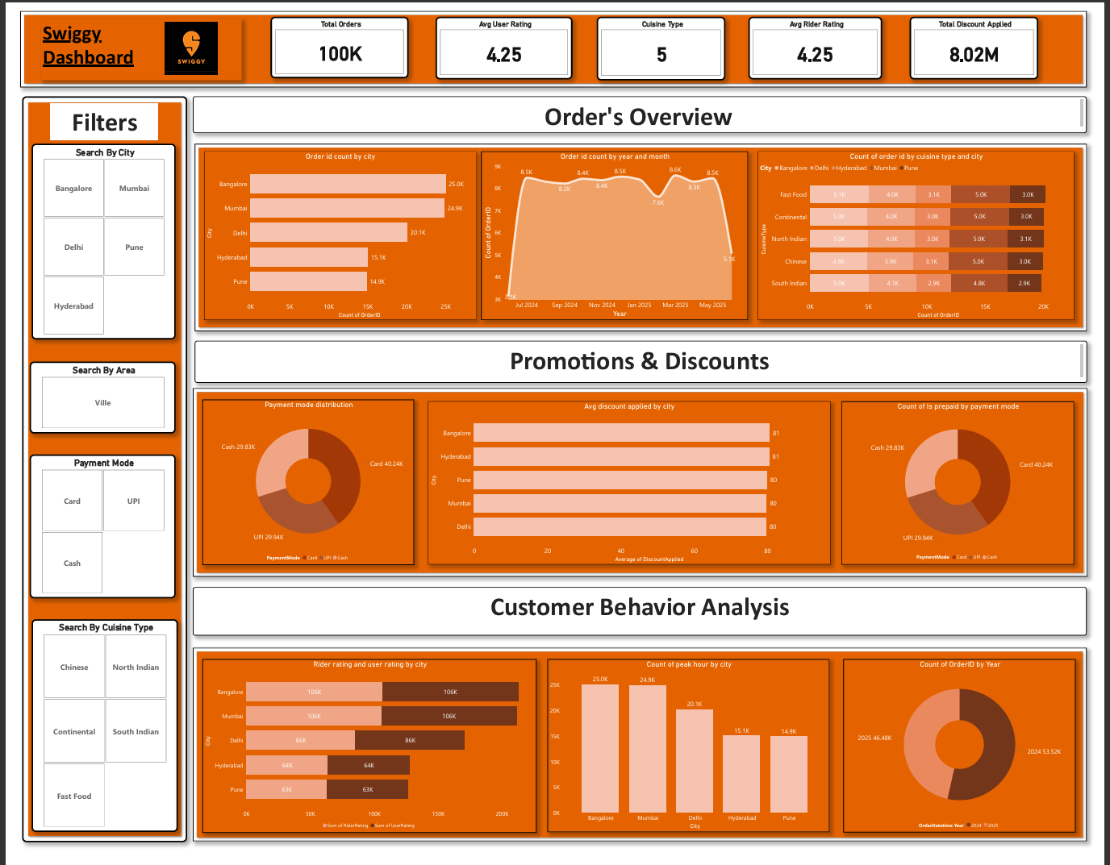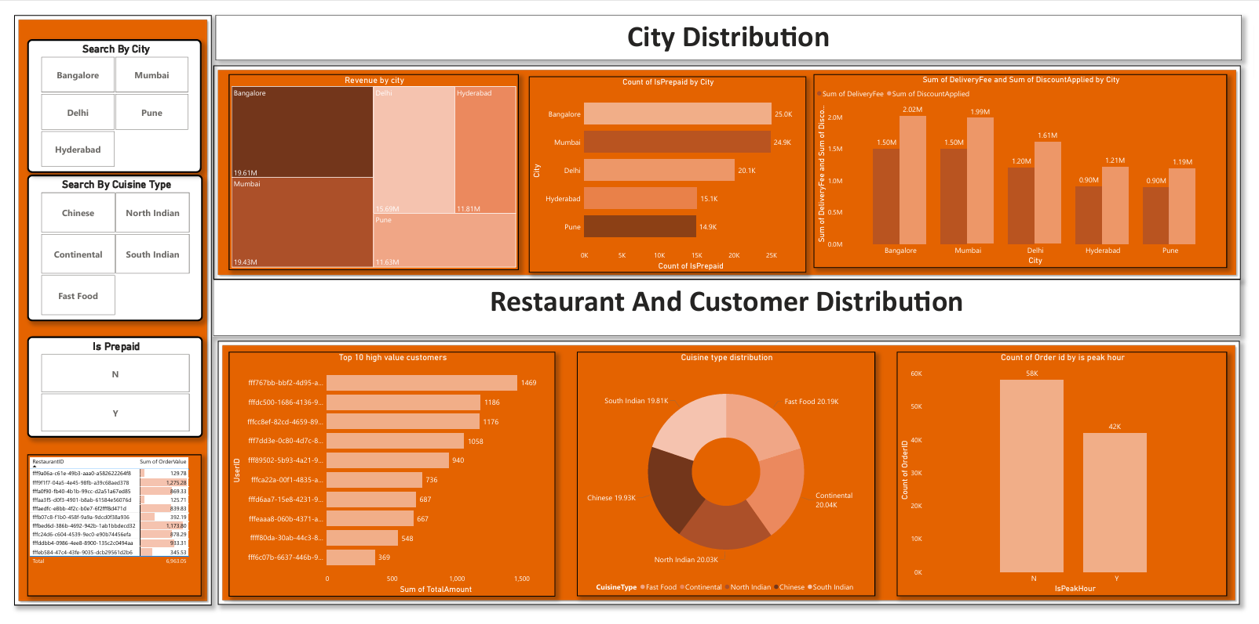

C)Tableau Public Edition Dashboard:
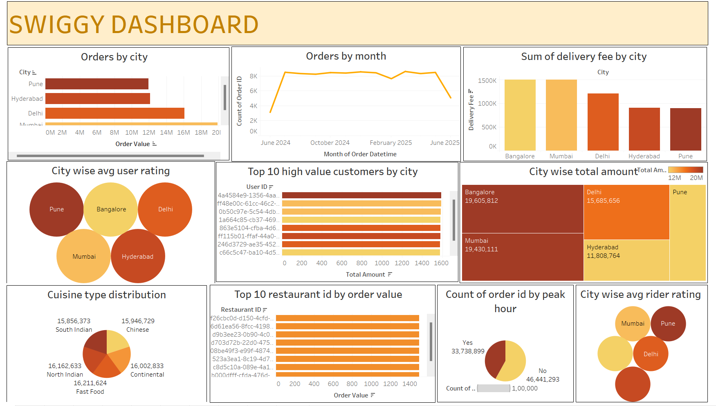

6)Challenges faced :
- In above dataset there is some amount of missing and null values these values are removed .
- The columns which not really important in the project are removed.
- Check the datatype of every column is correct or not if not it is corrected .
- Date and time formatting.
- Performance issue with large data.

7)Conclusion:
The Swiggy dashboard built in Excel, Power BI and Tableau offers a comprehensive overview of the food delivery platform’s key operational metrics. By transforming raw transactional data into meaningful visual insights, the dashboard effectively highlights critical business trends and performance indicators.

8)Future Scope:
1) Advanced Predictive Analytics
- Integrate machine learning models to forecast future orders, peak hours, or high-demand food items using historical data.
- Predict delivery times and customer churn rates for better planning.
2)Real-Time Data Integration
- Upgrade the dashboard to support real-time tracking of orders, delivery status, and rider performance.
- Monitor live order traffic across cities or restaurants to optimize delivery operations.
3)Mobile-Responsive Dashboards
- Make the dashboard mobile-friendly for quick business insights on the go, especially for Swiggy managers or restaurant partners.
4) Marketing and Campaign Tracking
- Track the performance of promotions, offers, and ad campaigns.
- Measure the impact of discounts on order volumes and customer retention.

